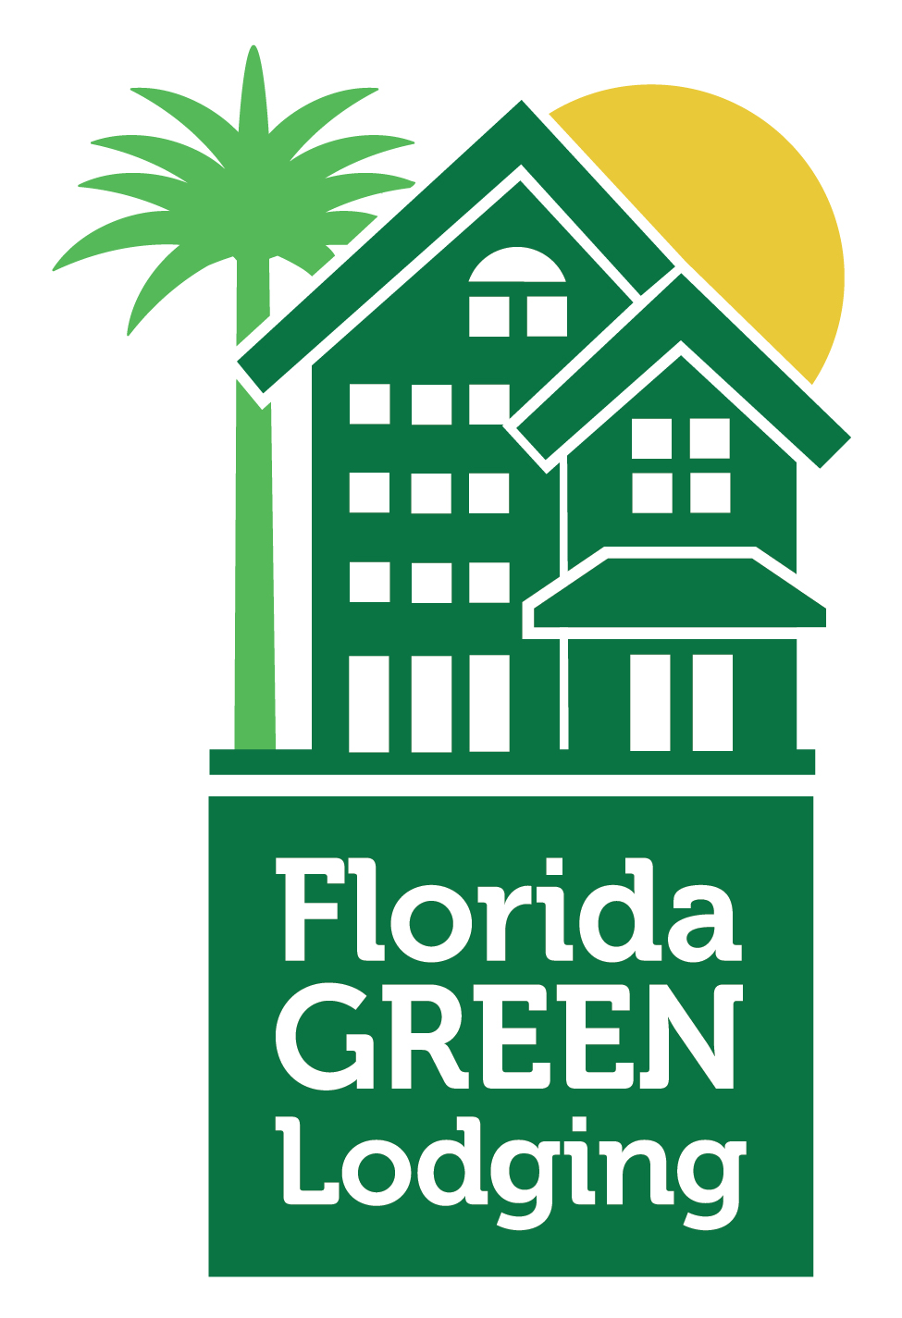

The Florida Green Lodging Program

The Hotel Name embraces the opportunity to enhance the quality of life for future generations through environmental initiatives implemented by the Florida Green Lodging Program. This voluntary effort introduced by the Florida Department of Environment Protection (DEP) encourages the lodging industry to protect and conserve Florida’s natural resources.
Environmentally friendly practices have been implemented throughout our hotel. The following represents some of the “green” initiatives we currently have in place:
- Initiative 1
- Initiative 2
- Initiative 3
- Etc
- Etc

The Hotel Name will continue to work with DEP to implement additional “green” practices. Should you have any comments or questions regarding our commitment to the environment feel free to inquire at the front desk. We also encourage you to complete the Green Lodging Guest Stay Survey on-line at www.FloridaDEP.gov/GreenLodgingFL.

